Atlas Altera HOI4 Mod Pitch

Starting Information | National Focus | National Spirit | Path Comparison | Other | Flavour

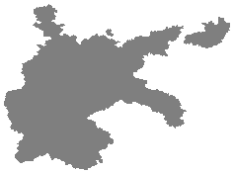
German Reich

Leader | Ideology | Sub-Ideology
Adolf Hitler | Ultranationalism | Nazism

The German Reich is entering a new age. The National Socialist government gained power by promising the German people an end to the Depression and the humiliation brought on by the Treaty of Versailles. One of the most pressing matters to the German Reich is the Remilitarisation of the Rhineland. Relying on the strong anti-war sentiments present in the European powers of Britain and France, the Third Reich hopes to gain public favour by marching their troops back into the Rhineland. While risky, as Britain and France may see this as a cause for confrontation, should it succeed, it will successfully sway the opinion of those ordinary Germans who do not believe in the Nazi cause.

Remilitarise the Rhineland
Removes the demilitarised zone in the Rhineland. 70 days.

Should the Remilitarisation of the Rhineland be successful, Adolf Hitler will be firmly entrenched in power, and free to model the nation as he sees fit. To him, the most important priority will be rearmament. By continuing to employ the usage of Mefo Bills, rearmament can be concealed and funded. However, the creator of the Mefo Bills and Minister of Economics, Hjalmar Schacht, is staunchly against the prioritisation of heavy, military industry, and believes the Mefo Bills should be used to support the recovery of civilian industry. Nazi ideologues such as Hermann Göring believe that the economy should be entirely restructured around the military.

In the summer of 1936, when the Iberian Wars break out, Hitler will be forced to choose between a more measured, balanced approach, as advocated by Schacht, or total devotion towards full rearmament. By choosing total devotion, the German Reich becomes locked into Operation Barbarossa. Hitler’s conviction was that war with Russia was inevitable in the near-future, and by choosing total devotion, it is clear that Hitler’s desire for war triumphs any attempts at holistic recovery.

Balanced Four-Year-Plan | Intensive Four-Year-Plan
✅Provides small, but longer buffs to civilian industry  ✅Allows Operation Barbarossa to be pursued whenever able  ✅Equal development of military and civilian industries  ❌Rearmament to take much longer  ❌Lack of powerful buffs to military production | ✅Provides more immediate construction buffs  ✅Provides major buffs to military production  ❌Does not enable fast growth of civilian industry  ❌Locks the German Reich into Operation Barbarossa in 1941

One of the most pressing matters for the German Reich is the development of the Wehrmacht. Established in 1935, the aim was to have an official standing army of 100,000 men, while, every year, the same number of men being trained. The sheer number of people needed for remilitarisation means an abandonment of traditional Prussian military values.
Traditional Prussian Military Values
Negative modifier on training time and manpower modifier.

To keep up with Hitler’s goal for remilitarisation, an additional 100,000 men must be deployed or training every year until 1939. Not keeping up with this risks negative modifiers. If this is kept up with, rewards such as army experience will be gained.

The development of the Heer (ground forces) also means an overhaul of German war strategies. Blitzkrieg becomes the main method of attack, which sees tank divisions, supported by planes, quickly knock out enemy divisions to bring a quick end to the war. To ensure that Blitzkrieg can be effectively incorporated, technologies such as radio must be kept up-to-date. If this is successful, Blitzkrieg tactics will be fully unlocked by 1940. Elsewhere in the army, there will be efforts to motorise and mechanise regular infantry.

Parallel to the development of the Heer is the development of the Kriegsmarine and Luftwaffe. The Luftwaffe will be centred around fighters and bombers, to be used to assist ground forces - however, if the remilitarisation goals are not kept up with, there is potential for greater investment and diversification of the Luftwaffe.

The Kriegsmarine is perhaps the weakest branch of the Wehrmacht. While the Anglo-German Naval Treaty of 1935 allowed for further investment into the navy, it is not believed to be at full capabilities until 1942. While U-Boats are initially effective, the technology for them must be constantly improved to ensure full effectiveness. Prioritising investment into the Kriegsmarine promises a more effective, dangerous navy, at the risk of the Heer and Luftwaffe becoming less effective.

Focus on Heer | Focus on Luftwaffe | Focus on Kriegsmarine
Requires quota of 100,000 newly trained men every year until 1939  ✅Increased mechanisation of regular infantry  ✅Buffs for development of tanks  ✅Results in a quick, powerful army  ❌Inflexible air force that is tied to the army  ❌Ineffective navy | Requires failure of 100,000 men quota  ✅Increased diversity of air force  ✅Buffs for development of planes  ✅Increased effectiveness alongside navy  ❌Less buffs for army | ✅Increased production & research buffs for navy  ✅Results in a more modern, powerful navy  ❌Less industrial capabilities for army and air force  ❌Less buffs for army and air force

Once Germany has completed their 1937 goals for remilitarisation, they are free to begin looking abroad. Germany can choose to intimidate the Austrian Chancellor, Kurt von Schuschnigg, into effectively surrendering his nation. Schuschnigg can attempt to hold a referendum for the future of Austria. If Austria does not have a foreign guarantor, this will fail, and Austria will be annexed into the German Reich. If Austria does have a foreign guarantor, the referendum will go ahead. Regardless of the outcome, a civil war between the Austrian Nazis and Free Austria will occur, the winner of which deciding if Austria is annexed by Germany or remains free. If the civil war lasts longer than a month, both Germany and Austria’s foreign guarantors will enter the war.

If the Anschluss of Austria, Frisse is the next target. With a somewhat sizable German minority and a key area in contesting the North Sea, the German Reich wishes to annex Frisse both as a show of force, to fulfill pan-German ambitions, and to use Frisian ports. Frisse has already been distancing itself from Britain, wishing to maintain neutrality and avoid future conflicts. Germany will make it clear that it wishes to annex Frisse. Britain can choose to concede, which is the more likely path due to anti-war sentiments and feelings of betrayal over Frisse distancing itself from London, or can choose to stand against Berlin.

Frisse will be sent an ultimatum, demanding that they join the German Reich. If both Frisse and Britain submit, Frisse will simply be annexed. If Frisse alone submits, Frisse will be annexed, but Britain will declare war. If Britain submits but Frisse remains defiant, Germany will declare war on Frisse.

Elsewhere in Europe, the Little Entente of Dacia, Czechia and Yugoslavia has effectively isolated German expansion without being involved in a war with a major power. Polonolithuany, while not officially backed by France or Britain, still remains a major regional power. At home, there are fears of a lack of oil, food and raw metal should Germany join a war. Germany is given the option of meeting with the People’s Republic of Russia to sign the Molotov-Ribbentrop Pact.

Signing the Pact | Not Signing the Pact
✅Non-aggression pact between Germany and Russia  ✅Adds production of oil, steel and chromium for as long as the Pact is active  ✅Military alliance in an invasion of Polonolithuany | ❌No non-aggression pact  ❌No increase in production of oil, steel and chromium

When Germany has met their 1939 goals for remilitarisation, they may demand Danzig from Polonolithuany. If Polonlithuany concedes, Danzig will be annexed by Germany and a non-aggression pact with Polonolithuany will be created. This also enables a minigame to increase influence in Polonolithuany.

If Polonolithuany refuses to cede Danzig, Britain and France will guarantee them. Germany can either decide to wait or to invade Polonolithuany, dragging France and Britain into the war as well. Russia will join the war 2 weeks after it begins, but only against Polonolithuany. After the invasion of Polonolithuany, Germany can continue down its war focuses.

At the outbreak of the war, the Society of Nations will pass a resolution demanding nations either directly join the war or support the war effort. At the initial stage of the war in Europea, only Britain and France directly join the war. As the war develops past the initial stage of the invasion of Polonolithuany, the members of the Society of Nations will be drawn into the conflict in different stages.

When Germany has successfully managed to capitulate or otherwise neutralise France, Wales, Flanders & Belgium, they can choose to either commit fully to Operation Sealion or focus on the Eastern Front. Choosing to focus on Operation Sealion sees Germany attempt a land invasion of Britain, knocking them out of the war even if their colonies and allies elsewhere continue the fight. By choosing to switch to the Eastern Front, Germany will aim to solidify their gains in Europea and gain a plethora of allies and puppets to have control over the continent.

In the Eastern Front, Germany will aim to gain control either through alliances or puppet states. Nations such as Hungary, Dacia and Macia are naturally predisposed to aligning themselves with the Axis.

Once Germany’s aims of subjugating eastern Europea are fulfilled, their attention will turn towards Russia. If Germany chose an Intensive Four-Year-Plan, they are locked into executing Operation Barbarossa in June 1941. If Germany chose a Balanced Four-Year-Plan, they can execute Operation Barbarossa whenever they wish, enabling Germany to turn their attention back West and finish off the Society of Nations.

At the onset of Operation Barbarossa, Germany will receive a slight buff that is renewed whenever a major city or province is captured. Should the Wehrmacht slow down, unless overextension is properly dealt with, more negative modifiers will be applied.

Should Germany win World War Two, they will have to spend the downtime consolidating their gains and cementing their power over Europea. A final confrontation with the free nations of Septentrea may be needed before the Greater German Reich is solidified.

Norway
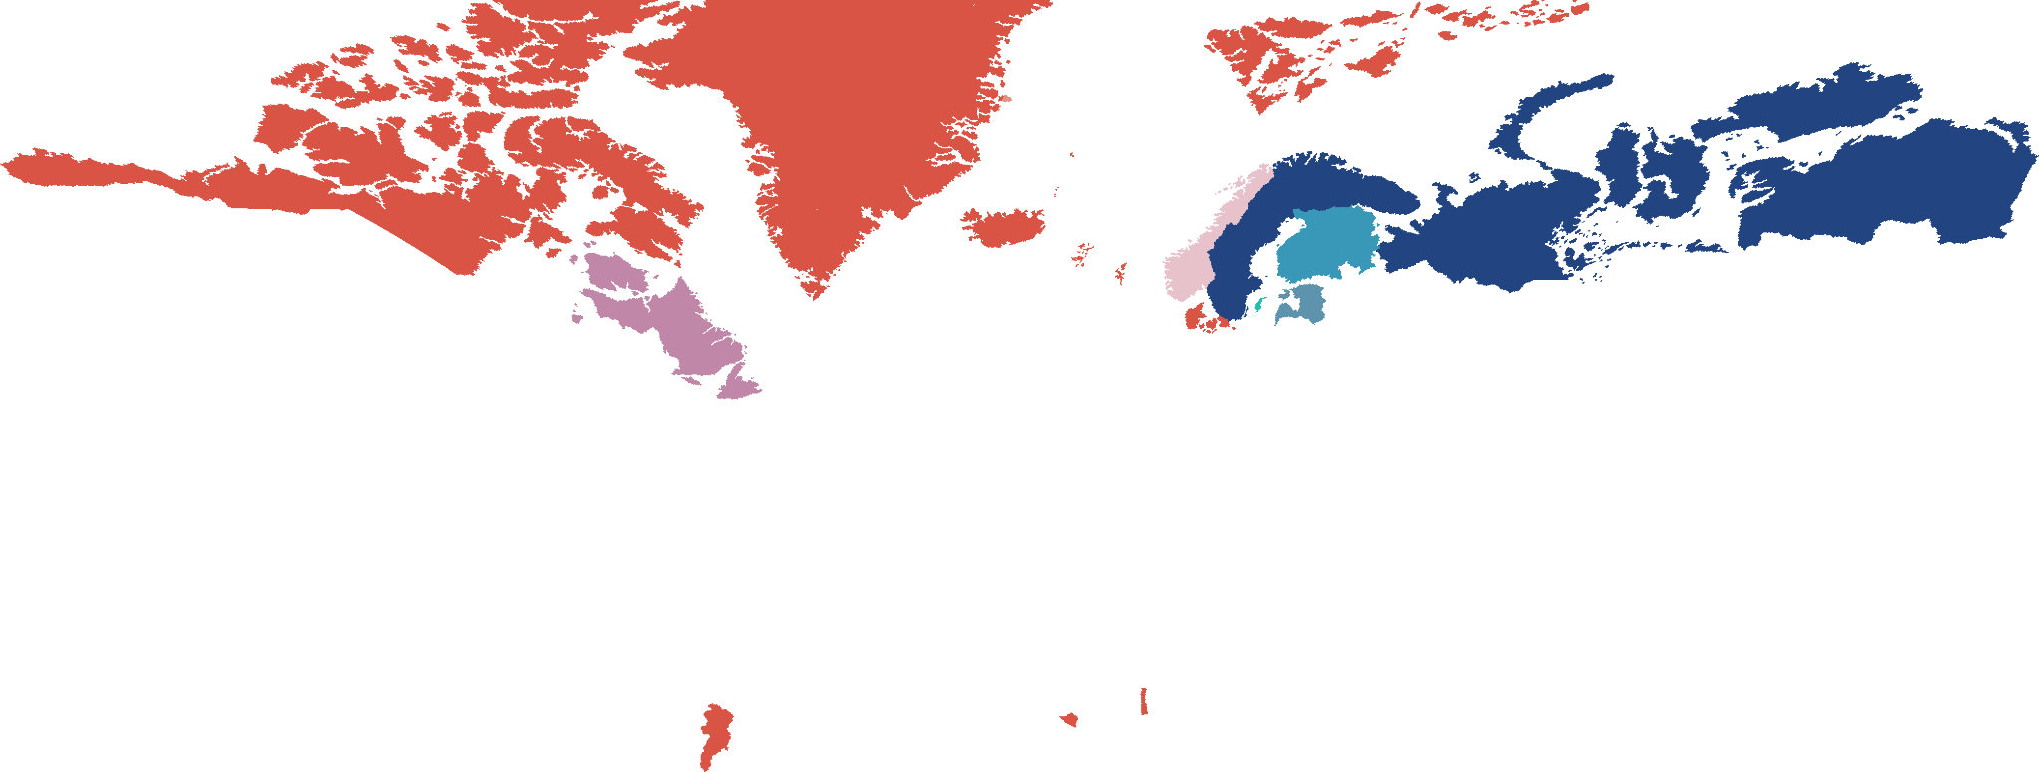
Norway is the political and economic union formed by Danmark and Swedeland in the wake of the First World War. The realm is formed up of 2 independent nations - the Kingdom of Danmark and Kingdom of Swedeland.

Danmark has three puppet states - Telemark, Windmark, and Rhimeland, all three of which are dominions. They are united behind the House of Glücksburg, whose head is Christian X. His brother, Haakon, was offered the Thelian throne when Norway confederated.

Danmark
King | Prime Minister | Ideology | Sub-Ideology
Christian X | Thorvald Stauning | Democracy | Social Democracy

Thelemark
Prince | Prime Minister | Ideology | Sub-Ideology
Haakon | Johan Nygaardsvold | Democracy | Social Democracy

Windmark
King | Prime Minister | Ideology | Sub-Ideology
Christian X | Frederick Gordon Bradley | Democracy | Conservatism

Rhimeland
King | Prime Minister | Ideology | Sub-Ideology
Christian X | Hermann Jónasson | Democracy | Liberalism

Meta: Frederick Gordon Bradley was an OTL politician in Newfoundland.

Danmark also has direct control over the colonial states of Hvalland, Helleland, Grenland, Iceland, Norwegian Guyane, the Spice Coast and Benin, and the overseas territories of Fairland and Shetland.

Swedeland has three puppet states - Livland, Gutland and Finland. All three are dominions. Unlike Danmark, all states of Swedeland have a single king.

Swedeland
King | Prime Minister | Ideology | Sub-Ideology
Gustaf V | Felix Hamrin | Democracy | Liberalism

Meta: Felix Hamrin does not resign as the PM in September 1932.

Livland
Prime Minister | Ideology | Sub-Ideology
Konstantin Päts | Democracy | Conservatism

Gutland
Prime Minister | Ideology | Sub-Ideology
Allan Rodhe | Democracy | Conservatism

Finland
Prime Minister | Ideology | Sub-Ideology
Pehr Evind Svinhufvud | Democracy | Conservatism

Swedeland also has direct control over the states of Taudland, Yurgland, and Smaugland.

